

Microsoft guide to Secure Remote Working

As the COVID-19 situation unfolds around the world, Microsoft is providing updates, guidance and support via:

* Our Microsoft global hub found here. <https://news.microsoft.com/covid-19-response/>
* Our Microsoft Australia Hub here: <https://www.microsoft.com/en-au/coronavirus>

Additionally, we will be updating this document and other localised WA content here: <https://aka.ms/RemoteWorkPerth/>

Based on questions we are receiving from WA customers, two ways Microsoft technology can support remote workers securely are:

**Collaboration, meetings, communication and coordination using Microsoft Teams -** Microsoft has published a list of ways that Microsoft Teams can help staff remain productive while working remotely. <https://www.microsoft.com/en-us/microsoft-365/blog/2020/03/10/staying-productive-while-working-remotely-with-microsoft-teams/>

**Secure Remote Access to Desktops and Applications using Windows Virtual Desktop –** Provide access to systems and applications via Virtual Desktops or Virtual Applications, using your organisations image on your own network. <https://www.microsoft.com/en-us/microsoft-365/blog/2019/09/30/windows-virtual-desktop-generally-available-worldwide/>

There are several resources we are making available to WA customers to support their remote working initiatives using these technologies

### Microsoft Events and Online Webinars Recordings

Microsoft Perth will be running a webinar on 20th March 2020 @ 10am to provide guidance to WA organisations. The webinar is link is assessible <https://aka.ms/MSPerthCOVID>

For those that cannot attend, the event will be recorded and can be viewed <https://aka.ms/RemoteWorkPerth>

## Your local Microsoft response team

For any questions or assistance, please contact one of your local team members who can assist:

* + Charles Poulsen, [charles.poulsen@microsoft.com](mailto:charles.poulsen@microsoft.com)
  + Wasim Anwar, [Wasim.Anwar@microsoft.com](mailto:Wasim.Anwar@microsoft.com)
  + Russel Anderson, [russela@microsoft.com](mailto:russela@microsoft.com)
  + Brian Carter, [Brian.Carter@microsoft.com](mailto:Brian.Carter@microsoft.com)
  + Antoinette Jago, [anjago@microsoft.com](mailto:anjago@microsoft.com)
  + Jiaranai Keatnuxsuo, [Jiaranai.Keatnuxsuo@microsoft.com](mailto:Jiaranai.Keatnuxsuo@microsoft.com)
  + Jonathan Wade, [jowade@microsoft.com](mailto:jowade@microsoft.com)
  + Zane Rahui, [zarahui@microsoft.com](mailto:zarahui@microsoft.com)

### Resources for IT / Administrators

Deployment Assistance from FastTrack: <https://www.microsoft.com/en-us/fasttrack/resources>

The hub of resources for Teams <https://docs.microsoft.com/en-us/microsoftteams/support-remote-work-with-teams>

#### Teams and Modern Workplace blog articles

* The top 9 ways Microsoft is enabling remote work for its employees: <https://www.microsoft.com/en-us/microsoft-365/blog/2020/03/12/top-9-ways-microsoft-it-enabling-remote-work-employees/>
* Top 5 Ways Azure Active Directory can help you enable remote work, securely: <https://techcommunity.microsoft.com/t5/azure-active-directory-identity/top-5-ways-your-azure-ad-can-help-you-enable-remote-work/ba-p/1144691>
* CISO security guidance for remote working: <https://www.microsoft.com/security/blog/?p=90736>

#### Windows Virtual Desktop enablement:

* + Deployment of WVD: <https://docs.microsoft.com/en-us/azure/virtual-desktop/tenant-setup-azure-active-directory>
  + Connecting to WVD via Web, Android, iOS, Mac or PC <https://docs.microsoft.com/en-gb/azure/virtual-desktop/connect-web/>
  + Technical FAQ: <https://gu-squidex-prod.azurewebsites.net/api/assets/31c18505-e926-4843-9de4-fc530cc18b37?version=0>

### User Guides and Training Materials

#### Teams end-user training materials:

* Microsoft Office and Teams training center: <https://support.office.com/en-us/office-training-center>
* Teams guides: <https://docs.microsoft.com/en-us/microsoftteams/enduser-training>
* Microsoft Teams training on Youtube Playlist [Microsoft Teams training](https://www.youtube.com/playlist?list=PLXPr7gfUMmKzR7_jXN5s886apYoHNC3Xk)

#### Windows Virtual Desktop end-user materials:

* User can connect from the Remote Desktop App available for Android, iOS, macOS and Windows or through a web browser at <https://rdweb.wvd.microsoft.com>, using their existing Work or School account.

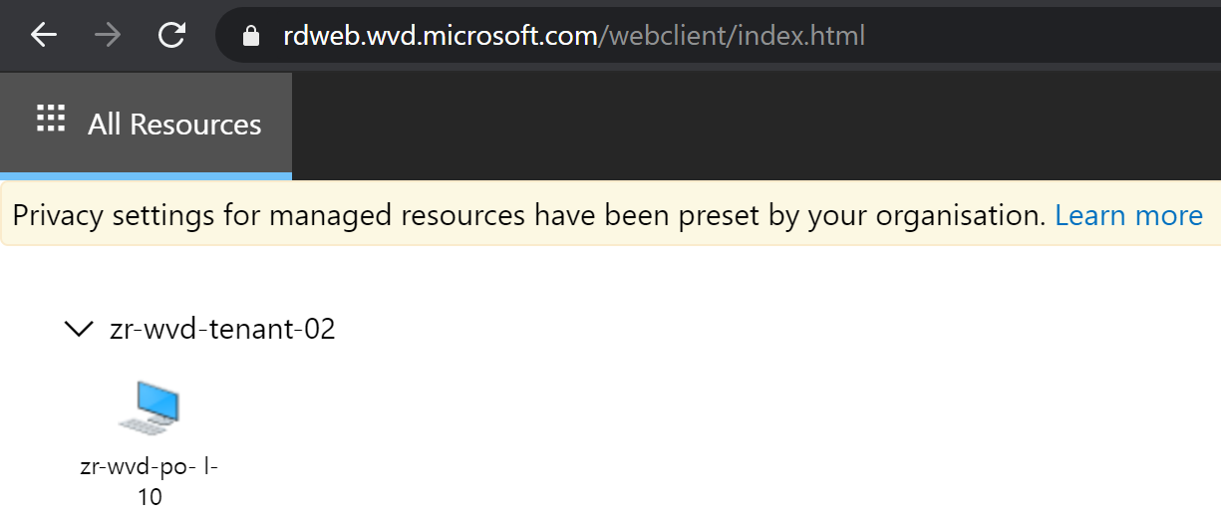

### Additional and Reference Information

As of Wednesday 18th March, the Microsoft Perth Team will commence remote work and will be available to answer questions or provide assistance over email, phone or Teams.

Organisations who currently have a Microsoft 365 E3 or A3 license are enabled for remote workers to use Teams, Office Pro Plus, or Azure Active Directory App Proxy. Microsoft 365 E3 or A3 licenses also provide access to Windows 10 Enterprise and Windows 7 Enterprise desktops and apps at no additional cost, when delivered through WVD. However, WVD does incur charges for the storage and compute used to power the desktops in Azure.